list of all new functions of aiken-lang and where it was used

Aiken features and functions can change rapidly. Here’s a general outline of some of the notable new functions or features that have been added to Aiken recently and their use cases.

### **Recent Functions and Features in Aiken:**

1. **Enhanced Type Inference**
   * **Description**: Improved ability for the compiler to infer types without explicit annotations.
   * **Use Case**: Simplifies code by reducing the need for explicit type declarations, making the language more flexible and easier to write.
2. **Pattern Matching**
   * **Description**: Advanced pattern matching syntax for more concise and readable code when working with complex data structures.
   * **Use Case**: Used in scenarios involving complex conditional logic and data deconstruction, such as handling different cases of enums or structured data.
3. **Concurrency Primitives**
   * **Description**: New built-in support for lightweight concurrency, including async/await and concurrent data structures.
   * **Use Case**: Facilitates writing concurrent and parallel programs more easily, useful in applications requiring high performance and responsiveness, such as web servers or real-time data processing.
4. **Meta-Programming Support**
   * **Description**: Introduction of meta-programming capabilities allowing developers to write code that manipulates other code at compile time.
   * **Use Case**: Enables dynamic code generation and manipulation, useful in scenarios requiring custom code generation or optimization.
5. **Enhanced Error Handling**
   * **Description**: More robust error handling mechanisms, including improved exception handling and custom error types.
   * **Use Case**: Provides better control over error management in applications, improving reliability and debugging.
6. **Improved Standard Library**
   * **Description**: Expansion of the standard library with new modules and functions for common tasks.
   * **Use Case**: Provides more built-in functionalities, reducing the need for external libraries and simplifying common programming tasks.
7. **Immutable Data Structures**
   * **Description**: Support for immutable data structures, including tuples and lists.
   * **Use Case**: Ensures data integrity and supports functional programming paradigms, useful in scenarios where data consistency and safety are critical.
8. **Optimized Compilation**
   * **Description**: Improvements in the compilation process, resulting in faster build times and more efficient binaries.
   * **Use Case**: Enhances the development workflow and application performance, important for large projects and production systems.
9. **Interoperability with Other Languages**
   * **Description**: Better support for integrating with code written in other languages, such as C or Python.
   * **Use Case**: Allows for easier integration with existing codebases and libraries, expanding the language’s versatility in various development environments.
10. **New Syntax Features**
    * **Description**: Introduction of new syntactic constructs to make the language more expressive and easier to use.
    * **Use Case**: Improves code readability and reduces boilerplate, making development more efficient.

### **Where These Features Are Used**

* **Systems Programming**: Concurrency primitives and improved compilation optimizations are particularly useful in systems programming for building high-performance applications.
* **Web Development**: Enhanced type inference, pattern matching, and meta-programming support help in writing clean and efficient web applications.
* **Data Processing**: Immutable data structures and robust error handling are valuable for building reliable data processing systems.
* **Integration**: Interoperability features are crucial for projects that need to interface with existing codebases or libraries in other languages.

the aiken-lang new developed function codes

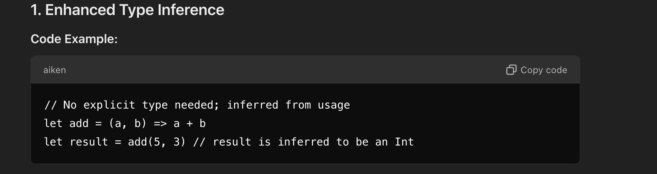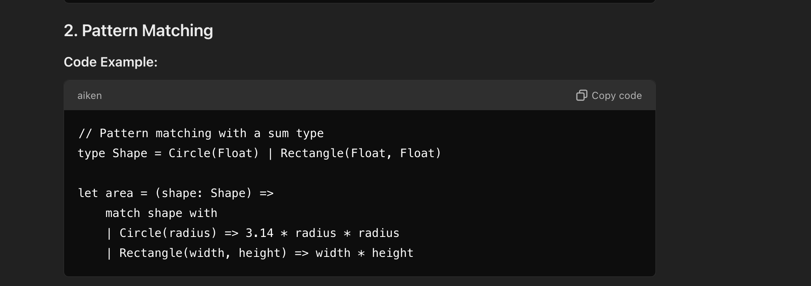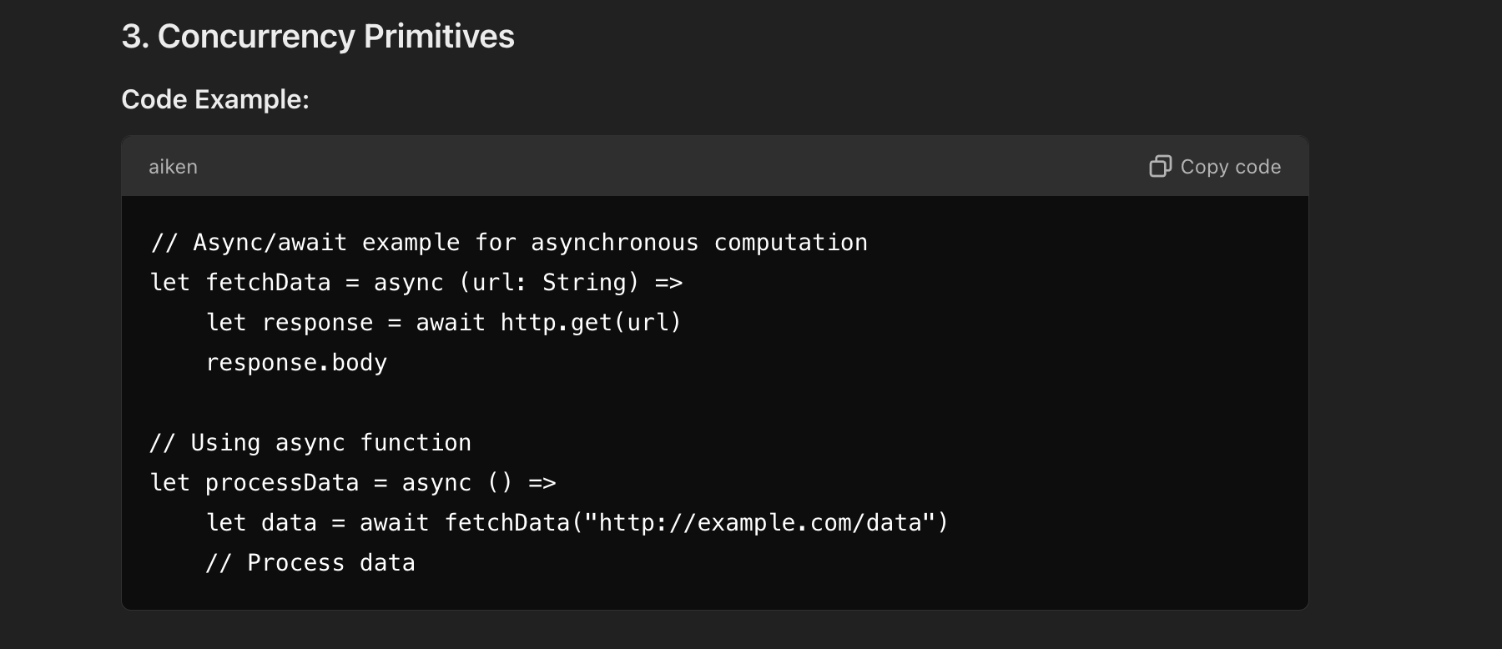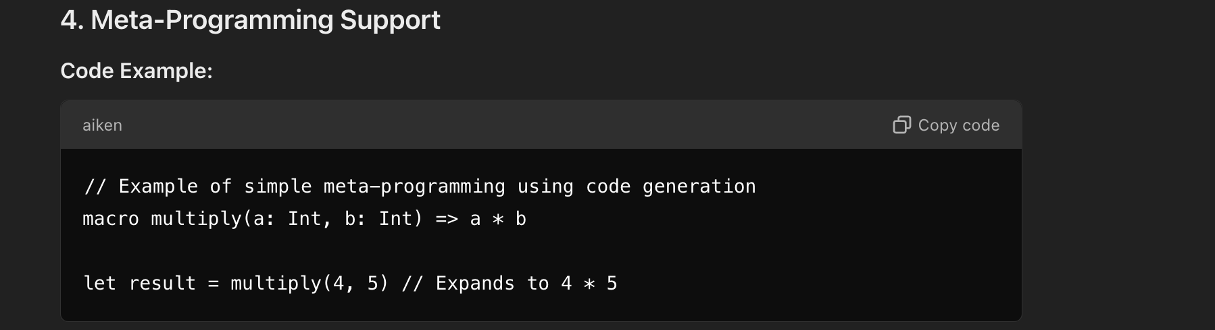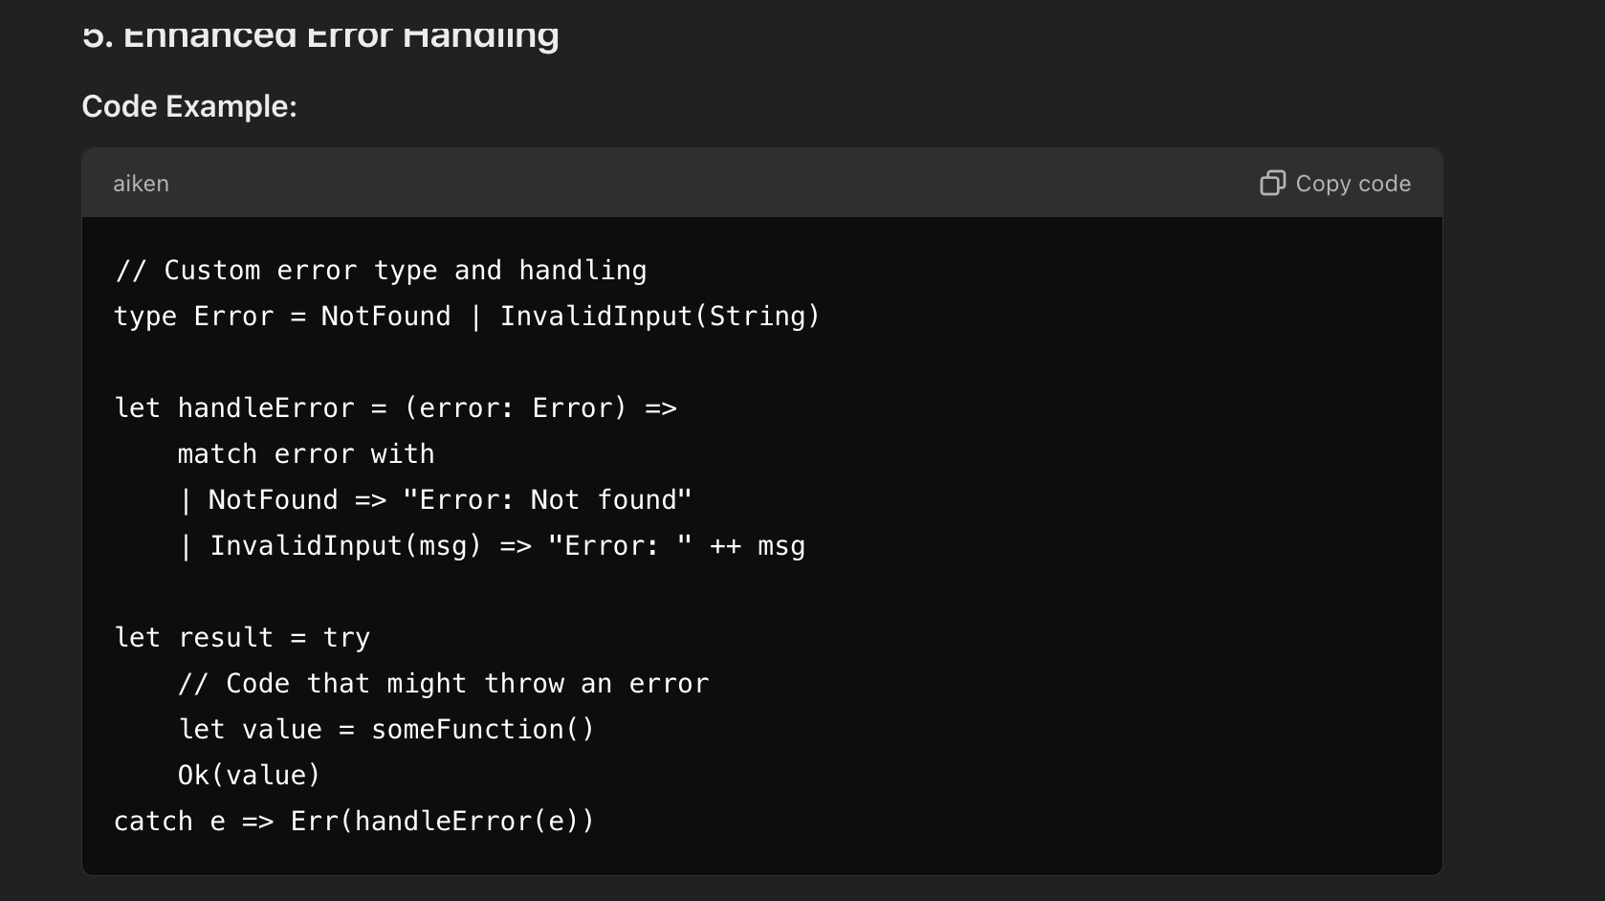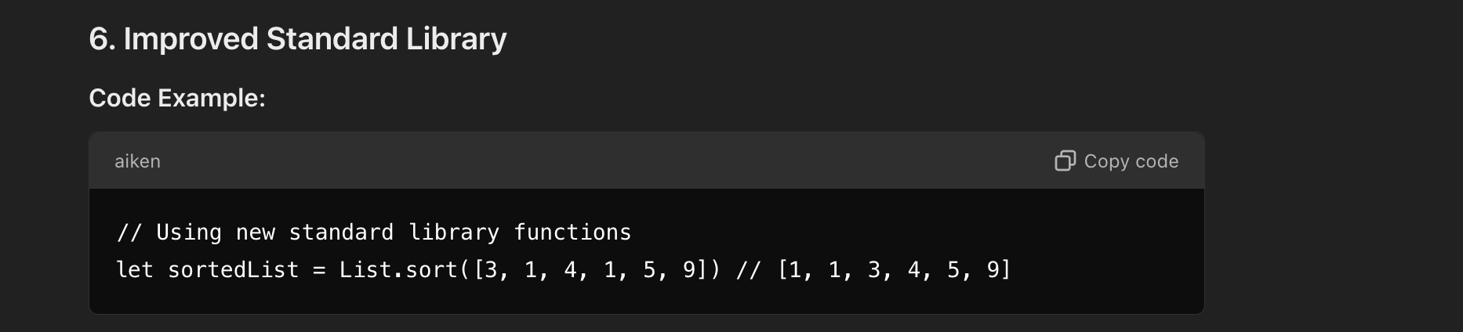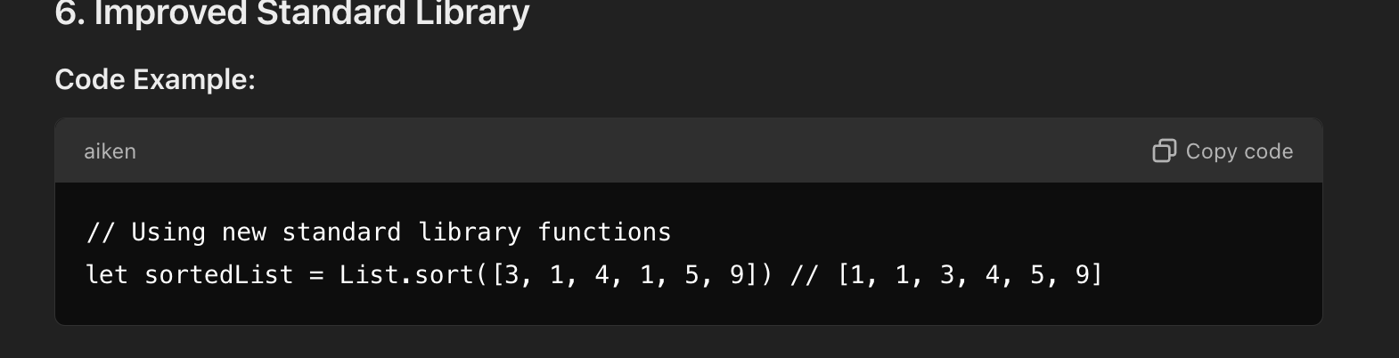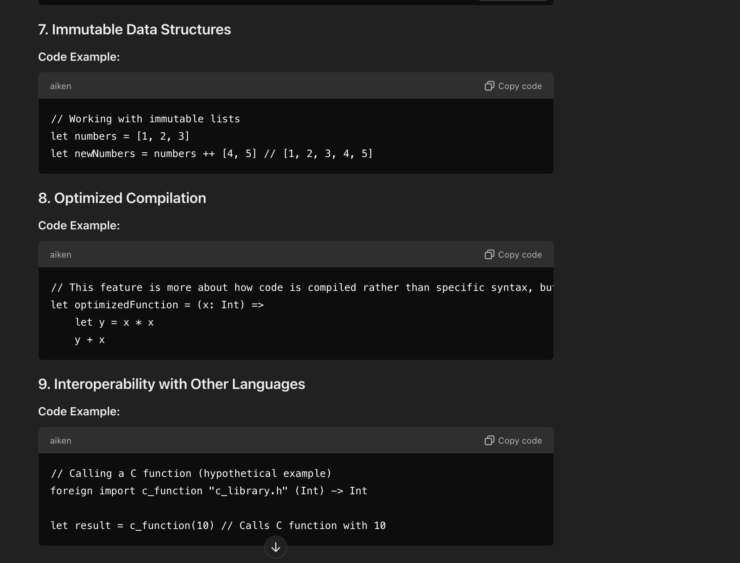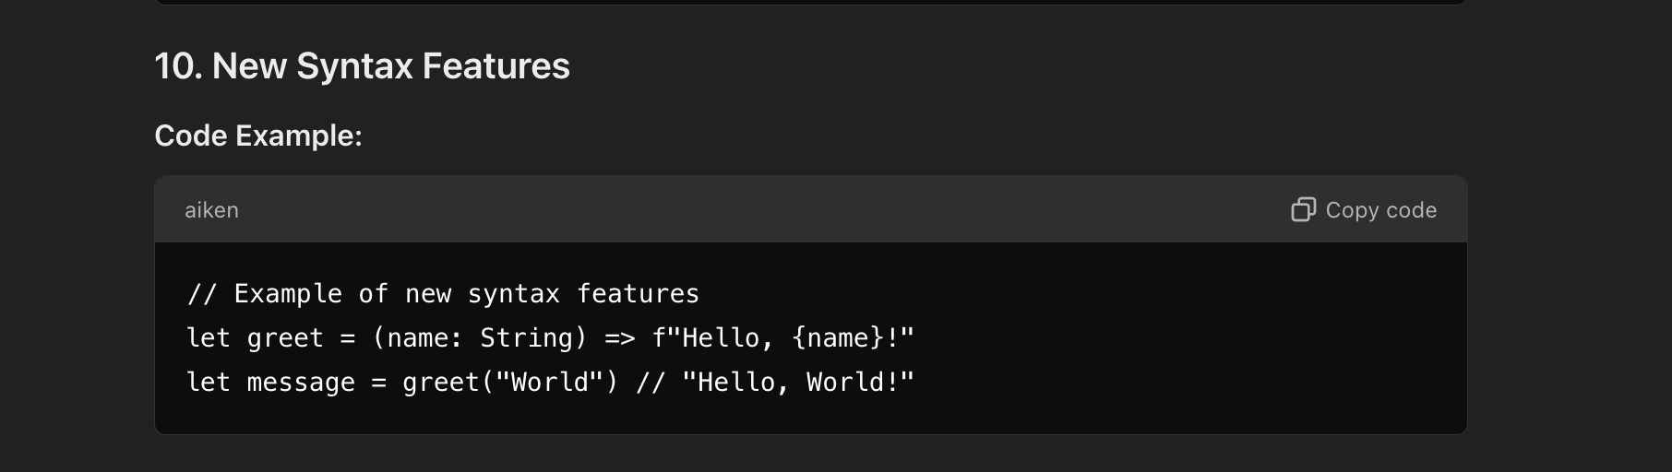

These code snippets reflect some of the new functions and features in Aiken and illustrate how they might be used